Home Work 2 (2007-09-14)
Submission deadline: 2007-09-22

Question 1: What is difference between <<extend>>, <<include>> and use case generalization relationships in use case diagrams. Emphasize your answer by giving an example. (Bonus Point 01)

The difference between include and extend relationships is the location of the dependency. Suppose we are going to add few use cases for the actor Dispatcher, say, OpenIncident, AllocateResources, and ConnectionDown.
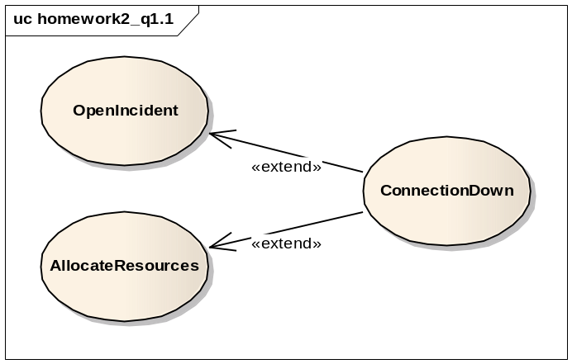
Figure 1.1
If we model the ConnectionDown use case with include relationships, the authors of OpenIncident and AllocateResources use case has to know about and include the ConnectionDown use case. Conversely, if we use extend relationships instead, only the ConnectonDown use case needs to be changed to extend the additional use cases. In short, exceptional cases are modeled with extend relationships, whereas common behavior shared by use cases are expressed by include relationships.

The extend relationships and generalization relationships are also different. In a extend relationship, each use case shows a different flow of events to achieve a different task. In Figure 1.1, the OpenIncident use cases depicts the actions which take place when the Dispatcher creates a new Incident, in contrary the ConnectionDown use case describes the actions that occur during network crisis.
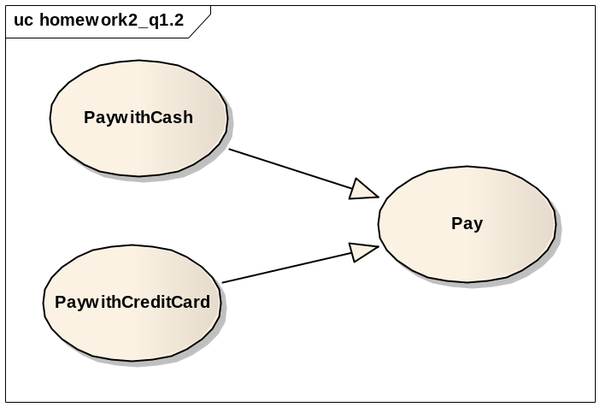
Figure 1.2
In Figure 1.2, PaywithCash and PaywithCreditCard both explain actions that occur during Payment, however at different abstraction levels.

Question 3: Consider the following Scenarios and refine the use case diagram given on page 03. You should create a new use case diagram, you should point out the places where other use cases get included, extended or generalized, and mark possible extension points.

